European Stroke Awareness Day 2026 – SAP-E SST campaign

Week 1: 12 May OVERVIEW
Week 2: 19 May FOCUS ON PREVENTION
Week 3: 26 May FOCUS ON HOSPITAL CARE
Week 4: 2 June FOCUS ON LIFE AFTER STROKE CARE
Week 5: 9 June FOCUS – THE NEED TO IMPROVE DATA
Week 6: 16 June INTERVIEWS – THE FUTURE

Week 1: 12 May OVERVIEW
NEWS

See separate Media Release.

NEWSLETTER

Subject: Progress, gaps and inequality: Europe’s latest Stroke Action Plan for Europe Stroke Tracker Services data is live

Headline: Europe’s stroke care shows real progress, but persistent gaps and inequality demand urgent action

Copy: Today, on European Stroke Awareness Day, we are publishing the latest data from the Stroke Action Plan for Europe's Stroke Service Tracker, the most comprehensive picture yet of stroke care across 49 European countries.

The 2024 data confirm real progress in some areas. 29 countries now have national prevention plans, record numbers of countries are meeting the thrombectomy treatment target, early rehabilitation has seen its biggest single-year improvement and early supported discharge is now available in 11 countries (up from seven in 2023).

But stroke unit access has not improved, development of new national stroke plans has stalled with only 20 across Europe, gaps in secondary prevention and follow-up are leaving survivors at risk of a second stroke, fewer than 40% of countries offer a structured follow-up after stroke and persistent inequities in care across Europe is threatening to leave many Southern and Eastern European countries behind.

Click to read more https://linkly.link/2i7kg
Click to access your data https://linkly.link/2i4zM

SOCIAL MEDIA

Visual: Graphic

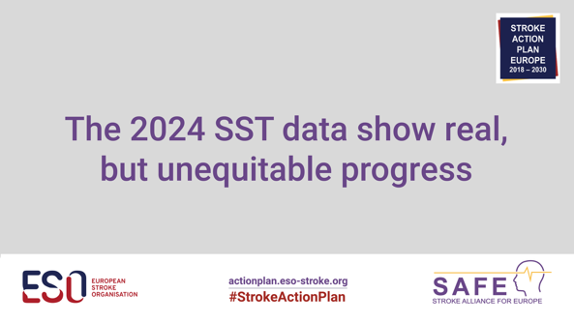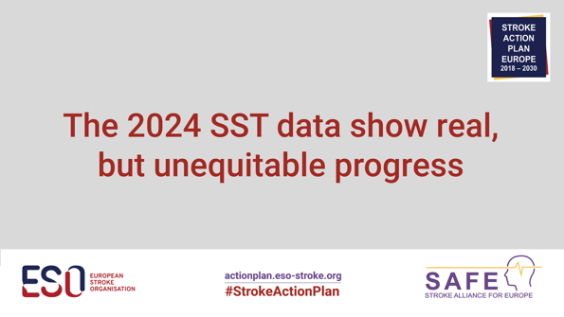

LinkedIn / Facebook

🧠 Today, on #EuropeanStrokeAwarenessDay, we are publishing the latest data from the #StrokeActionPlan for Europe's Stroke Service Tracker, giving us the most comprehensive picture yet of stroke care across 49 European countries.
The 2024 data show real progress in Europe:

✅ 29 countries have national prevention plans
✅ 24 countries are now meeting the thrombectomy treatment target
✅ Early rehabilitation is now available in at least 90% of stroke units in 31 countries

But significant gaps remain:
⚠️ Only 9 countries admit 90% of people with a stroke to a stroke unit
⚠️ Development of national stroke plans has stalled, established in only 20 countries
⚠️ Only 7 countries are meeting the target of providing thrombolysis to 20% of patients
⚠️ Gaps in secondary prevention and follow-up are leaving survivors at risk of a second stroke
⚠️ Fewer than 40% of countries offer a structured follow-up after stroke
Where you live in Europe still determines the care you receive. This is not acceptable.

Access the full data 👉 https://linkly.link/2i4zM

#EuropeanStrokeAwarenessDay or #ESAD2026
#StrokeServiceTracker
#StrokeActionPlan
#StrokeActionNow
#CVHealth

@European Stroke Organisation
@Stroke Alliance for Europe

X / BlueSky
📣 New #SST data: 49 countries, real progress, but stroke unit access unchanged & gaps in secondary prevention leaves survivors at risk. It is unacceptable that where you live determines your care.

👉 https://linkly.link/2i4zM

#ESAD2026

Week 2: 19 May FOCUS ON PREVENTION

SOCIAL MEDIA

Visual: Graphic

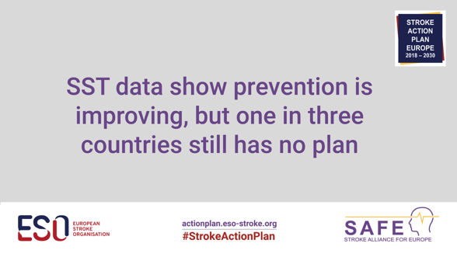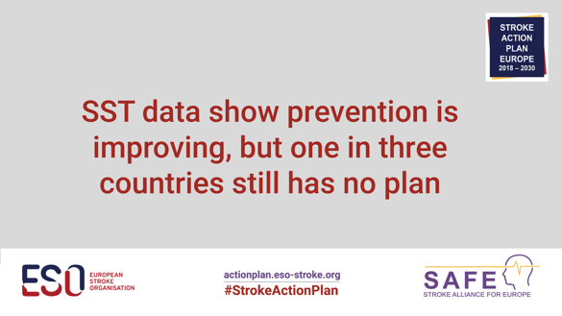

LinkedIn / Facebook

🧠 More than 80% of strokes are preventable. So how is Europe doing on prevention?

The latest Stroke Action Plan for Europe #StrokeServiceTracker data show encouraging progress:

✅ 29 countries now have a primary prevention plan, up from 24 in 2023
✅ 17 countries have established screening for key stroke risk factors
✅ 10 countries now have a brain health plan, tracked for the first time

These are positive changes. But with prevention plans still absent in more than a third of European countries, there is no room for complacency. Every country must now act now.

Find yours 👉 https://linkly.link/2i4zM

#EuropeanStrokeAwarenessDay or #ESAD2026
#StrokeServiceTracker
#StrokeActionPlan
#StrokeActionNow
#CVHealth

@European Stroke Organisation
@Stroke Alliance for Europe

X / BlueSky

🛡️ 29 European countries have a stroke prevention plan, up from 24 = real progress. But plans are absent in more than a third of countries – governments need to do more. Find your country’s data 👉 https://linkly.link/2i4zM

#ESAD2026

Week 3: 26 May FOCUS ON HOSPITAL CARE

SOCIAL MEDIA

Visual: Graphic

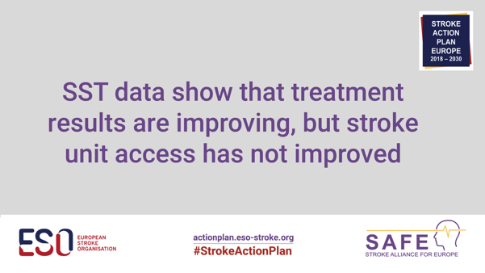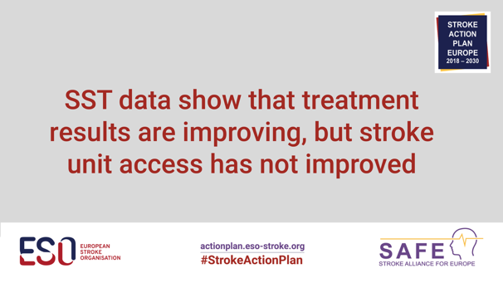

LinkedIn / Facebook

🧠 The latest Stroke Action Plan for Europe #StrokeServiceTracker data bring the strongest acute stroke treatment results to date, but stroke unit access has not improved in the last year.

The good news:

✅ 24 countries now meet the thrombectomy treatment target
✅ Early rehabilitation is now available in at least 90% of stroke units in 31 countries, up from 24 in 2023
✅ Early supported discharge has grown from 7 to 11 countries

The concerns ⚠️
❌ Only 9 countries admit 90% of people with a stroke to a stroke unit
❌Only 7 countries are meeting the target of providing thrombolysis to 20% of patients
❌ Only 3 countries ensure 90% of patients are admitted into a stroke unit within 24 hours of hospital arrival
❌ The time to access to treatment varies dramatically between countries

Time is brain. The gap between the best and the rest is stark. Countries must now ask: why are others achieving what we are not?

Find your country’s data 👉 https://linkly.link/2i4zM

#EuropeanStrokeAwarenessDay or #ESAD2026
#StrokeServiceTracker
#StrokeActionPlan
#StrokeActionNow
#CVHealth

@European Stroke Organisation
@Stroke Alliance for Europe

X / BlueSky

Updated #SST data:
✅ Improved thrombectomy results
✅ Early rehabilitation access increased

Only 9 countries admit 90% of people with a stroke to a stroke unit, unchanged from 2023. Find your country’s data 👉 https://linkly.link/2i4zM

#ESAD2026

Week 4: 2 June FOCUS ON LIFE AFTER STROKE CARE

SOCIAL MEDIA
Visual: Graphic / video (TBC)

LinkedIn / Facebook

Based on data in 25 countries, 16% (range 2.2-26%) of stroke survivors in Europe will go on to have another stroke. That is not inevitable, it is the consequence of systems that too often lose track of patients the moment they leave hospital.

The data tell a stark story:
⚠️ Fewer than 40% of countries offer structured follow-up at 3-6 months after stroke
⚠️ Those that do, reach on average only around half of their patients
⚠️ Only 16 countries use a structured post-stroke checklist
⚠️ Secondary prevention data is missing from nearly half of all countries

Surviving is not the finish line, every country should prioritise follow-up, secondary prevention and the support needed to help people live well after stroke.

Find your country’s life after stroke data 👉 https://linkly.link/2i4zM

#EuropeanStrokeAwarenessDay or #ESAD2026
#StrokeServiceTracker
#StrokeActionPlan
#StrokeActionNow
#CVHealth

@European Stroke Organisation
@Stroke Alliance for Europe

X / BlueSky

Based on data from 25 countries 16% of stroke survivors will have another stroke. Less than 40% of countries offer structured follow-up. Surviving stroke is not the end, we must do better.

👉 https://linkly.link/2i4zM

#ESAD2026
#LifeAfterStroke
Week 5: 9 June FOCUS – THE NEED TO IMPROVE DATA

SOCIAL MEDIA

Visual: Graphic / video (TBC)

LinkedIn / Facebook

📊 You cannot improve what you cannot measure. Across Europe, gaps in stroke data are making it harder to drive improvement where it is needed most.

The latest #StrokeServiceTracker data reveal:
❌ Quality and auditing programmes is in place in only 20 countries
❌Secondary prevention data is missing from nearly half of all countries
❌ Rehabilitation transition plan data is absent from 75% of countries
❌ Just 8 countries audit stroke care beyond the hospital setting

Countries that cannot measure their stroke care cannot make the case for investment, identify where the system is falling short or demonstrate improvement over time. Strong national stroke registries are needed as they are the foundation on which better care is built.

Find where your data gaps are 👉 https://linkly.link/2i4zM

#EuropeanStrokeAwarenessDay or #ESAD2026
#StrokeServiceTracker
#StrokeActionPlan
#StrokeActionNow
#CVHealth

@European Stroke Organisation
@Stroke Alliance for Europe

X / BlueSky

📊 Secondary prevention #SSTdata is missing from nearly half of European countries. Without better data, it is hard to know where care is falling short and how to fix it.

Find your gaps👉 https://linkly.link/2i4zM

#ESAD2026
#LifeAfterStroke
Week 6: 16 June INTERVIEWS – THE FUTURE

SOCIAL MEDIA

Visual: Graphic / video (TBC)

LinkedIn / Facebook

⏳ With less than 10 years until the Stroke Action Plan for Europe's 2030 deadline - we are asking: is Europe on track?

Where Europe is moving in the right direction:
✅ 24 countries meeting the thrombectomy treatment target
✅ Early rehabilitation improving significantly
✅ Early supported discharge has grown from 7 to 11 countries
✅ Prevention plans growing across the continent

Where urgent action is needed ⚠️
❌ Only 9 countries admit 90% of people with a stroke to a stroke unit
❌ National stroke plans confirmed in just 20 countries
❌Only 7 countries are meeting the target of providing thrombolysis to 20% of patients
❌ Too many stroke survivors will have another stroke
❌Huge gaps in stroke data is making it harder to drive improvement where it is needed most
❌ The inequities in stroke care across Europe, with many Southern and Eastern European countries lagging behind

The Stroke Action Plan for Europe gives every country their #SST data, the framework and the roadmap.

We urge every government, health system and national stroke community to use it, and to act on them.

The time is now.

Find your data 👉 https://linkly.link/2i4zM

#EuropeanStrokeAwarenessDay or #ESAD2026
#StrokeServiceTracker
#StrokeActionPlan
#StrokeActionNow
#CVHealth

@European Stroke Organisation
@Stroke Alliance for Europe

X / BlueSky

⏳ Not long to the 2030 SAP-E deadline. National stroke plans in only 20 countries and too many survivors have another stroke. The #SST data exist. The #StrokeActionPlan exists. Now we need action.

Find your gaps👉 https://linkly.link/2i4zM

#ESAD2026

