RES-Q+

Brain Awareness Week: For publication on 20 March 2026

Content

- Project overview for website (long)
- News for website (short)
- Newsletter (e-mail, link to story on website)
- Social media

MEMBERS

Members may use their discretion to decide which channels are most effective

VISUALS

- Video:
- RES-Q+ logo

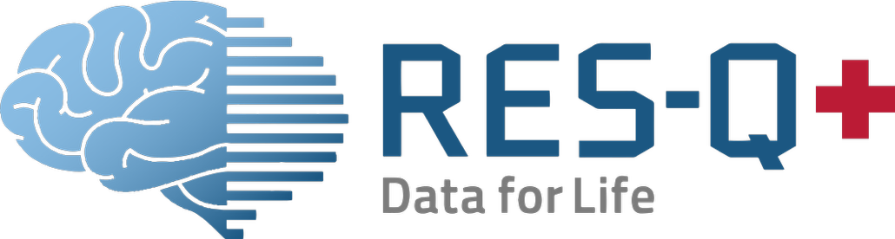

CONTENT

1. Project overview for website (long)

Visual: Project logo

RES-Q+: Connecting hospital care and home recovery after stroke
The RES-Q+ project, funded by EU Horizon, aims to improve stroke care by combining care quality data, digital technology and artificial intelligence. Building on the global RES-Q registry, an international database that helps hospitals track and improve stroke treatment, RES-Q+ aims to extend this support for stroke survivors beyond their hospital stay.
One of the innovations of the project is the virtual assistant (VA), a digital tool co-created with stroke survivors, developed to support recovery during the months after leaving hospital.

A digital companion for recovery
Recovery does not end when someone leaves hospital. Many stroke survivors need to take medications, keep an eye on their health and watch for any new symptoms at home, often with only brief and infrequent checkups.
The VA acts as a friendly, companion that is always available. It helps stroke survivors to:
- Track blood pressure and other important stroke risk factors
- Complete short, conversational questionnaires about mobility, mood and daily functioning
- Keep an overview of medications
- Store important health documents securely
- Access trusted, clinician-approved information about stroke and recovery
The VA is clear about its role. It does not replace medical professionals and does not provide personalised medical advice. When needed, it encourages stroke survivors to contact their healthcare team.
Why this matters for stroke survivors
Checkups after a stroke are often limited in time and important changes can happen between appointments. By collecting and summarising information for healthcare professionals through the RES-Q platform, the VA helps connect what happens at home with what is discussed in meetings with healthcare teams.
For people recovering from stroke, this means a smoother process that is more joined-up, with fewer things getting lost or forgotten and more meaningful conversations with their health care team. By helping people feel less alone once the leave the hospital, the VA can support safer recovery and boost confidence during their life after stroke.

Hendrik Knoche, project co-leader at Aalborg University, says:
“We developed the virtual assistant together with stroke survivors and clinicians to address real challenges after discharge. By capturing what happens between appointments and presenting it clearly to doctors, the tool helps make follow-up visits more meaningful and better informed.”
Arlene Wilkie, Director General of SAFE, says:
“Stroke recovery does not end when a stroke survivor leaves hospital. By connecting home recovery with hospital checkups, clinical follow-up, the virtual assistant helps ensure that no important details or changes are missed. This is an important step towards more personalised and joined up stroke care.”

For more information
- See video: TBC
- Click to visit the RES-Q+ website: https://www.resqplus.eu
- Contact SAFE for more information: research@safestroke.eu



RES-Q+ has received funding from the European Union under grant agreement No 101057603.

2. News for website (short)

Visual: project logo

RES-Q+ develops virtual assistant to strengthen stroke follow-up care
The European RES-Q+ research project aims to improve stroke care by combining the global RES-Q registry, an international database tracking stroke care to improve treatment quality, with digital tools and artificial intelligence.
As part of this work, stroke survivors and clinicians have co-developed a virtual assistant (VA) to support survivors after they leave hospital.
The VA will help them track important health issues (such as blood pressure), track what medicine to take when, store key documents and invite users to complete short questionnaires while providing summaries to healthcare professionals to support smoother and more joined up hospital checkups.
By strengthening the connection between hospital care and home recovery, the VA aims to improve the care, support and long-term outcomes for stroke survivors.

Arlene Wilkie, Director General of SAFE, says:
“Stroke recovery does not end when a stroke survivor leaves hospital. By connecting home recovery with hospital checkups, the virtual assistant helps ensure that no important details or changes are missed. This is an important step towards more personalised and joined up stroke care.”

For more information
- See video: TBC
- Click to visit the RES-Q+ website: https://www.resqplus.eu
- Contact SAFE for more information: research@safestroke.eu

RES-Q+ has received funding from the European Union under grant agreement No 101057603.

3. Newsletter

Visual: Project logo

RES-Q+: Supporting stroke recovery beyond hospital care

The EU-funded RES-Q+ project is extending stroke care beyond the hospital, using digital tools and patient data to support recovery at home.
One of its innovations, a virtual assistant, will support stroke survivors at home, helping them monitor their day-to-day health, track of which medications to take when and share updates with their healthcare professionals between hospital checkups.
Click to read more

4. Social media

Visual: Video

Facebook / LinkedIn

Brain Awareness Week day 5: RES-Q+ - Supporting stroke recovery beyond hospital care

Stroke recovery does not end when someone leave hospital, it is the start of a new and often difficult period for stroke survivors.
The RES-Q+ project, funded by EU Horizon, aims to improve stroke care by combining care quality data, digital technology and artificial intelligence. Building on the global RES-Q registry, an international database that helps hospitals track and improve stroke treatment, the project aims to extend this support for stroke survivors beyond their hospital stay with a virtual assistant (VA).
The VA will help stroke survivors track important health issues (such as blood pressure), track what medicine to take when, store key documents and invite users to complete short questionnaires while providing summaries to healthcare professionals to support smoother and joined up hospital checkups.
As Arlene Wilkie, Director General of SAFE, explains:
“Stroke recovery does not end when a stroke survivor leaves hospital. By connecting home recovery with hospital checkups, the virtual assistant helps ensure that no important details or changes are missed. This is an important step towards more personalised and joined up stroke care.”
Hendrik Knoche, project co-leader at Aalborg University, adds:
“We developed the Virtual Assistant together with stroke survivors and clinicians to address real challenges after discharge. By capturing what happens between appointments and presenting it clearly to healthcare professionals, the tool helps make follow-up visits more meaningful and better informed.”
By strengthening the link between stroke survivors and healthcare teams, RES-Q+ aims to support safer recovery and better long-term outcomes.

Read more about this project [link]

#BrainAwarenessWeek
#RES-Q+
#StrokeResearch
X / BlueSky

#BrainAwarenessWeek day 4: RES-Q+.
Stroke recovery doesn’t end after a hospital stay. EU-funded RES-Q+ has developed a virtual assistant to help stroke survivors track health, manage medications & support better follow-up care. Connecting home recovery with clinic visits can mean safer recovery and better long-term outcomes.
🔗 Learn more: [Insert link]

#BrainAwarenessWeek
# RES-Q+
#StrokeResearch

