**European Stroke Awareness Day 2025**

**13 May 2025 European Stroke Awareness Day**

**NEWS – Long copy**

**Headline: Europe makes strides in stroke care, but stark inequities persist, new data reveal**

**The 2023 Stroke Services Tracker data shows progress in stroke care planning and treatment access, but persistent disparities demand urgent attention.**

**[City], [Date]**

New data from the Stroke Action Plan for Europe’s 2023 Stroke Service Tracker, launched today, show encouraging progress in stroke care across Europe – but also highlight serious inequalities that urgently need to be addressed.

A total of 47 countries contributed to the latest dataset, providing the most comprehensive picture yet of stroke care across the continent. The findings show improvements in national planning, emergency treatment and prevention. However, too many people who have had a stroke still face major challenges in accessing the care, rehabilitation and follow-up they need.

**Stronger national commitment to stroke care**

There is growing political commitment to tackling stroke. The number of countries with a national stroke plan has risen from 16 in 2022 to 24 in 2023, with 16 more countries currently developing one. Importantly, 30 countries now involve Stroke Support Organisations in shaping national stroke strategies and guidelines, ensuring people with lived experience have a voice in how care is delivered. Lithuania, Poland and Slovakia have recently joined this effort.

Programmes aimed at preventing stroke are also becoming more common. Lithuania, Sweden, the Netherlands and Germany are among the countries that have launched or expanded national prevention efforts in the past year, bringing the total to 23.

**Improved access to life-saving treatment – but too slowly**

Access to key emergency treatments for ischaemic stroke (which happens when a blood clot or blockage stops blood flow to parts of the brain) is improving, but unevenly. On average, 15.4% of eligible patients received clot-busting drugs (intravenous thrombolysis), and 5.9% underwent mechanical thrombectomy – a procedure to remove a clot directly from the brain.

Seven countries have now met the European benchmark of giving thrombolysis to at least 20% of patients, and 14 have reached the target of delivering thrombectomy to over 7.5%, based on high-quality data. Five more countries hit this goal using data of lower quality.

However, delays in treatment remain a major problem. Only seven countries managed to achieve the recommended 'door-to-groin' time – the time from arrival in hospital to starting thrombectomy – of 60 minutes or less. In 12 countries, this delay was over 90 minutes, reducing the chances of a good recovery.

**Ongoing challenges in stroke unit care, rehabilitation and follow-up**

Despite some progress, the organisation of stroke services and monitoring of quality still fall short in many areas. The goal of admitting at least 90% of stroke patients to a specialist stroke unit is only met in nine countries with reliable data. In contrast, some countries admit fewer than one in four patients to stroke units – and others don’t collect this data at all.

Only 22 countries monitor the quality of stroke unit care. The picture is even more concerning when it comes to rehabilitation after hospital discharge. Just 11 countries have systems in place to monitor the quality of rehabilitation services.

Early rehabilitation is available in stroke units in 22 countries (although data quality is low in eight). However, there has been little progress in ensuring patients have a rehabilitation and care transition plan which are essential for continued recovery. Just five countries systematically monitor whether such plans are given, while 14 estimate that they are provided, but without proper tracking.

Follow-up care after stroke also varies widely. Only 11 countries report that at least 90% of patients receive follow-up and just four countries offer structured follow-up that meets recognised standards.

**Prevention of further strokes and improving patient outcomes**

Preventing another stroke is crucial – nearly one in four strokes happens in someone who has already had one. But across Europe, there is little data on how well countries are doing in providing secondary prevention, or how many patients are getting the medication and support they need. This makes it difficult for policymakers to know where to act.

These inequalities in care are reflected in outcomes. In some regions, death rates within 30 days of stroke remain worryingly high, pointing to major differences in access to emergency treatment, rehabilitation services and longer-term support.

**Life after stroke: support remains limited**  
Only 13 countries report having a dedicated national programme for life after stroke. While many address important aspects of recovery, support remains inconsistent. Twelve countries include ongoing health management in their programmes, while 10 focus on emotional adjustment and mental wellbeing. Eleven countries offer support for everyday activities and practical challenges, and an equal number provide information and guidance for both stroke survivors and their carers.

**A call to action: bridging the gap between potential and practice**

**"The 2023 Stroke Service Tracker data show that while momentum is building in some areas – particularly in national planning and access to acute therapies – major gaps in organisation, delivery and equity of stroke care persist,” said Professor Hanne Christensen, Chair of the Stroke Action Plan for Europe. “There is no room for complacency. Countries must take these insights and act decisively to bring data collection and stroke care up to the standards that every person affected by stroke deserves.”**

**Arlene Wilkie, Director General of the Stroke Alliance for Europe (SAFE), added: “It is unacceptable that in 2023 we still see such wide disparities in access to stroke unit care, early rehabilitation and life after stroke support. Stroke survivors need holistic and continuous care. We call on all national governments and policy makers to do better in providing the essential services required for all those affected by stroke.”**

**Professor Simona Sacco, President of the European Stroke Organisation (ESO), emphasised: “The Stroke Action Plan for Europe provides countries with the framework they need to close the gap between aspiration and delivery. These data are both a roadmap and a challenge – to work smarter, faster and more equitably.”**

**For more information on your country’s data, the Stroke Action Plan for Europe and the Stroke Service Tracker, visit** <https://bit.ly/3GuHpKu>**.**

|  |
| --- |
| **About SAP-E and the Stroke Service Tracker**  **The Stroke Action Plan for Europe (SAP-E), launched in 2018, provides a strategic blueprint to improve stroke prevention, care and life after stroke support by 2030. The Stroke Service Tracker (SST) was developed as a monitoring tool to evaluate Europe’s progress against the SAP-E targets, providing valuable insights for national stakeholders to drive improvements.**  **Europe faces over 1.1 million strokes each year, causing nearly 460,000 deaths. Nearly 10 million people live with stroke’s long-term effects. The economic burden is immense – €60 billion in 2017 – and is projected to rise to €86 billion by 2040 without urgent reform.**  **The SST continues to be a vital instrument for mapping progress and exposing areas where countries fall short. It is a call for action, innovation and investment to ensure every stroke survivor in Europe has access to high-quality, timely and equitable care – no matter where they live.** |

**NEWSLETTER**

**Headline: 2023 SST data: Stroke care across Europe is improving, but not fast or equal enough**

The newly released 2023 Stroke Service Tracker data from the Stroke Action Plan for Europe highlights encouraging progress in national planning and access to life-saving treatments. However, it also exposes major gaps in rehabilitation, follow-up and life after stroke support

**>>> Click-through to shorter news story (OR long news story)**

**Headline: Europe makes strides in stroke care, but stark inequities persist**

The Stroke Action Plan for Europe (SAP-E) Stroke Service Tracker (SST) has just released its latest data, offering a detailed look at how stroke care and support are evolving across the 47 participating European countries.

The good news? There is clear progress in national stroke planning, access to acute treatments and primary prevention.

But there is a long way to go, particularly when it comes to equitable access, timely treatment, rehabilitation and life after stroke support.

**Key findings:**

* **24 countries now have a national stroke plan,** up from 16 in 2022, and more countries are involving stroke support organisations in decision-making.
* **Access to life-saving emergency treatments are on the rise,** with 15.4% of ischaemic stroke patients **(which occurs when a blood clot or blockage stops blood flow to parts of the brain)** receiving clot busting **intravenous thrombolysis** and 5.9% receiving mechanical thrombectomy (to remove the clot from the brain. But significant disparities remain.
* **Stroke unit access still falls short.** Only nine countries meet the goal of admitting 90% of patients to a stroke unit. In others, rates are below 25% or not reported.
* **Post-stroke rehabilitation and life after stroke care remain fragmented**. Just 11 countries provide follow-up for at least 90% of stroke survivors and only 13 countries report having a dedicated life after stroke programme.

We are urging national leaders to take targeted action to close these gaps. The SAP-E provides the framework, now it is time for implementation and accountability.

*“There is no room for complacency. Countries must take these insights and act decisively to bring data collection and stroke care up to the standards that every person affected by stroke deserves,” says Professor Hanne Christensen, Chair of SAP-E.*

**For more information on your country’s data, the Stroke Action Plan for Europe and the Stroke Service Tracker, visit** <https://bit.ly/3GuHpKu>**.**

|  |
| --- |
| **About SAP-E:** The SAP-E is a collaborative initiative launched by the Stroke Alliance for Europe and the European Stroke Organisation aimed at improving stroke care across Europe through research, advocacy and policy development. By bringing together stakeholders from across the healthcare spectrum, SAP-E seeks to set standards and drive positive change to improve outcomes for individuals affected by stroke. |

**Social channels**

**Post 1**

**Content:** Hanne videohttps://youtu.be/BQiEs9egBas

[](https://youtu.be/BQiEs9egBas)

**LinkedIn / Facebook**

📊 The 2023 #StrokeServiceTracker is live!

Professor. Hanne Christensen, Chair of the Stroke Action Plan for Europe, shares key insights:

✔️National stroke plans are accelerating

✔️ Access to life-saving acute treatments is improving

⚠️ But equity remains a major challenge.

Professor Christensen calls for countries to focus on two core targets:

1. Continued adoption of National Stroke Plans covering the entire chain of stroke care to be developed, funded and implemented.

2. Establishment of systems to collect and report stroke data.

🔍 Read the key takeaways and why urgent action is still needed 👉

**[link to LONG version on own website or link to SAP-E:** <https://bit.ly/3GuHpKu>**]**

#EuropeanStrokeAwareness

#StrokeActionPlanforEurope

**European Stroke Organisation**

**Stroke Alliance for Europe**

**X**

📊 The 2023 #StrokeServiceTracker is live

Professor Hanne Christensen on the 2023 data:

✔️ Progress in acute treatment

⚠️ Gaps in stroke units, rehab, follow-up & life after stroke

🔍 The key takeaways & why urgent action is needed 👉

**[link to LONG version on own website or link to SAP-E:** <https://bit.ly/3GuHpKu>**]**

#ESAD2025

**Post 2**

Visual: Graphic focus on the positives

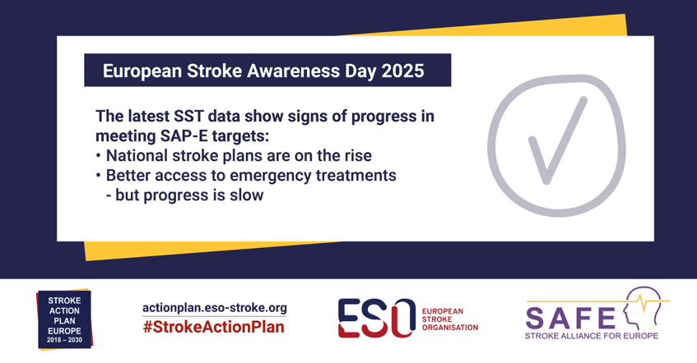

**LinkedIn / Facebook:**

**🧠** The new #SST data shows that stroke care in Europe is showing some positive signs of progress:

✅ National stroke plans are growing – from 16 in 2022 to 24 in 2023  
🙌 30 countries now involve patient organisations in shaping stroke strategies  
🛡️ Prevention programmes now exist in 23 countries  
💉 Access to critical treatments like IVT and MT is steadily increasing

Read more **👉**

**[link to LONG version on own website or link to SAP-E:** <https://bit.ly/3GuHpKu>**]**

#EuropeanStrokeAwarenessDay / #ESAD2025  
#StrokeActionPlanforEurope

**European Stroke Organisation**

**Stroke Alliance for Europe**

**X**

🧠 The new #SST data show positive signs of improvement in stroke care.

✅ 24 countries now have national stroke plans

💉 Access to life-saving treatments like IVT & MT is rising

🛡️ Prevention programmes now in 23 countries

Read more 👉

**[link to LONG version on own website or link to SAP-E:** <https://bit.ly/3GuHpKu>**]**

#EuropeanStrokeAwarenessDay

**Post 3**

Visual: Graphic focus on the negatives

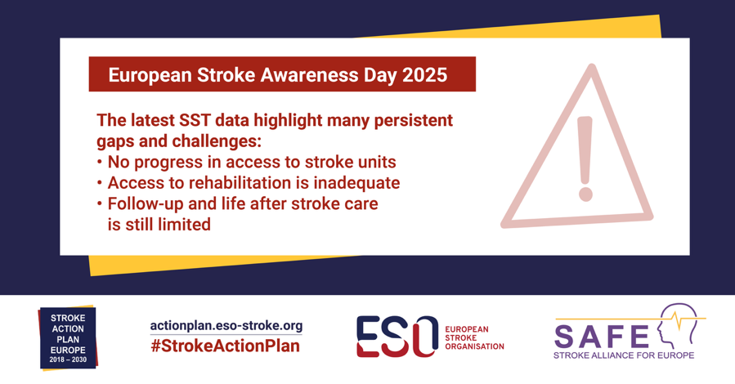

**LinkedIn / Facebook**

**🧠** The new #SST data highlight persistent gaps in stroke care across Europe:

⚠️ Only 9 nations meet SAP-E’s 90% stroke unit access target

⚠️ Mechanical thrombectomy delays exceed 90 min in 12 countries

⚠️ Early rehabilitation and secondary prevention remain under-monitored

⚠️ Just 5 countries track rehab transition plans after discharge

⚠️ Only 13 countries provide a life after stroke program

Read more 👉

**[link to LONG version on own website or link to SAP-E:** <https://bit.ly/3GuHpKu>**]**

#EuropeanStrokeAwarenessDay / #ESAD2025  
#StrokeActionPlanforEurope

**European Stroke Organisation**

**Stroke Alliance for Europe**

**X**

**🧠 New #SST data reveal big gaps in stroke care across Europe:**

**⚠️ Only 9 nations meet 90% stroke unit access target**

**⚠️ Rehab & prevention under-monitored**

**⚠️ Just 5 track rehab transition plans**

**⚠️ Only 13 with life after stroke programs**

**👉**

**[link to LONG version on own website or link to SAP-E:** <https://bit.ly/3GuHpKu>**]**

**#ESAD2025**

**15 May 2025**

**Content: Graphic focus on overview of data**

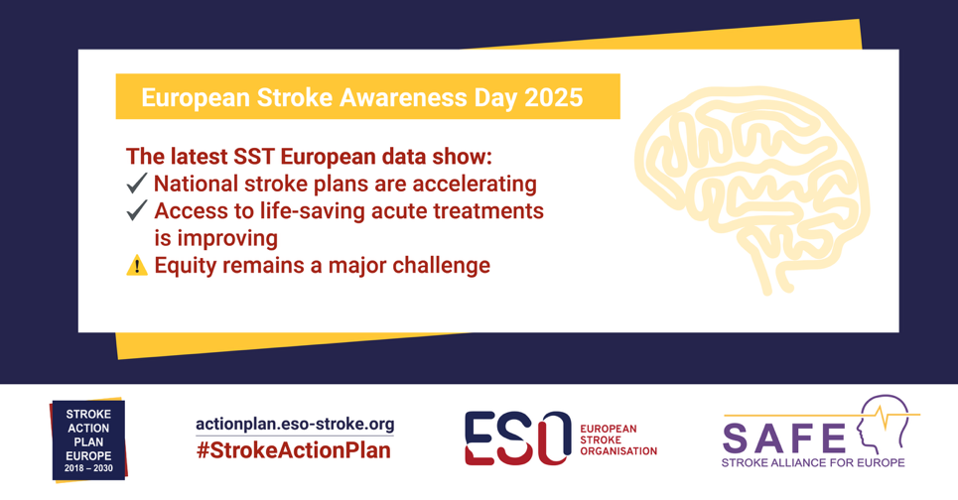

**LinkedIn / Facebook**

📊 **New 2023** #StrokeActionPlanforEurope **#StrokeServicesTracker data launched on #EuropeanStrokeAwarenessDay**

**It showed that Europe is making progress in stroke care, with more countries developing national stroke plans and expanding access to critical treatments. But the data also reveal stark disparities in care, rehabilitation and life after stroke.**

**📈 24 countries now have a national stroke plan**

**🏥 IVT given to 15.4% of ischaemic stroke patients**

**🩺 MT provided in 5.9% of cases**

**❗ Only 9 countries admit 90% of stroke patients to stroke units**

**🧑‍⚕️ Just 11 countries provide structured follow-up care for at least 90% of stroke survivors**

⚠️ **Only 13 countries report having a dedicated life after stroke programme**

**Read the key takeaways and why urgent action is still needed**

**👉 [link to LONG version on own website or link to SAP-E:** <https://bit.ly/3GuHpKu>**]**

#ESAD2025

**X**

The new data from the 2023 #StrokeServicesTracker was published on #ESAD2025. Europe is making progress in stroke care planning and treatment access – but there are major gaps in rehab and life after stroke.

Read more 👉

**[link to LONG version on own website or link to SAP-E:** <https://bit.ly/3GuHpKu>**]**

#StrokeActionPlanforEurope

**27 May 2025**

**Visual: Poll**

**X / LinkedIn**

**Question: How will you use your local Stroke Services Tracker Data? I will identify the key gaps in my country and…**

**Option 1: Approach my Health Minister to advocate for improvements**

**Option 2: Approach my local hospital to advocate for improvements**

**Option 3: Approach my local stroke support organisation to improve life after stroke services**

**Option 4:** I will contact my local Stroke Action Plan for Europe National Coordinator to get involved in progressing national stroke plans

**Option 5: I am unsure how to use it**

**Poll duration: 1 week**

**Find out more about Stroke Services Tracker Data** <https://bit.ly/3GuHpKu>

#EuropeanStrokeAwarenessDay / #ESAD2025  
#StrokeActionPlanforEurope  
@ESOstroke    
@StrokeEurope