European Stroke Awareness Day 2025

6 May – lead up to ESAD

Social posts

Visual: Aleš Tomek video https://bit.ly/4cRl8m2

LinkedIn / Facebook
📣 Countdown to the launch of the latest #StrokeServiceTracker data on #EuropeanStrokeAwarenessDay.

The SST is the annual data update from 47 countries which shows how stroke care is evolving across Europe, where the gaps remain and how we can improve outcomes for people affected by stroke.

💬 Hear Assistant Professor Aleš Tomek explain why it is so important.
How are you planning to use your country’s data?

[Own call to action OR Sign up to the SAP-E newsletter to be the first to hear about the new data: https://bit.ly/3Ew8KLL]
#EuropeanStrokeAwarenessDay / #ESAD2025
#StrokeActionPlanforEurope
@ESOstroke
@StrokeEurope

X

Visual: Still from video



📣 Countdown to the launch of the latest #StrokeServiceTracker data on #EuropeanStrokeAwarenessDay. 💬 Hear Assistant Professor Aleš Tomek explain why it is so important.

[Own call to action OR Sign up to the SAP-E newsletter to be the first to hear about the new data: https://bit.ly/3Ew8KLL]

#EuropeanStrokeAwarenessDay / #ESAD2025
#StrokeActionPlanforEurope
@ESOstroke
@StrokeEurope

8 May – lead up to ESAD

Social posts

Visual: Diana Wong Ramos video https://bit.ly/3ECTv3D

LinkedIn / Facebook
📣 In the countdown to #EuropeanStrokeAwarenessDay, stroke survivor & advocate Diana Wong Ramos shares why the #StrokeServiceTracker is so powerful.

💬 “Policymakers need data.”

The SST is the annual data update from 47 countries which shows how stroke care is evolving across Europe, where the gaps remain and how we can improve outcomes for people affected by stroke.

How are you planning to use your country’s data?

[Own call to action OR Sign up to the SAP-E newsletter to be the first to hear about the new data 👉 https://bit.ly/3Ew8KLL]

#ESAD2025
#StrokeActionPlanforEurope

@European Stroke Organisation

X

Visual: Still from video

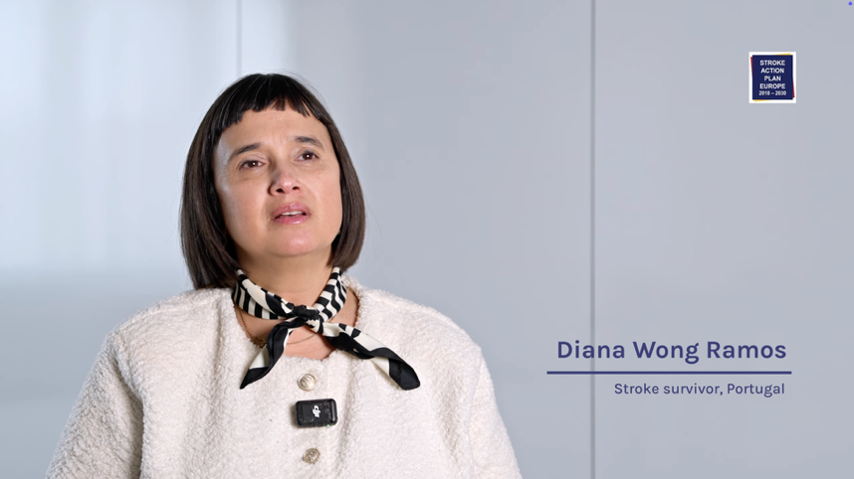

📣 In the countdown to #EuropeanStrokeAwarenessDay, stroke survivor & advocate Diana Wong Ramos shares why the #StrokeServiceTracker is so powerful. 💬 “Policymakers need data.”

[Own call to action OR Click to view 👉 https://bit.ly/3ECTv3D]

#ESAD2025
#StrokeActionPlanforEurope

