**Application for board member role**

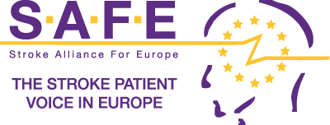

**(Please complete all sections)**

|  |  |
| --- | --- |
| Full name: | click |
| Name of member stroke support organisation: | click |
| Position held in member stroke support organisation: | click |
| Country of member stroke support organisation: | click |

|  |
| --- |
| What contribution do you hope to make to SAFE and the stroke patient community as a member of the board? |
| click |

|  |
| --- |
| What personal, expertise and professional strengths will you bring to SAFE and the stroke community? Mention any relevant experience. |
| click |

|  |
| --- |
| How would your election to the SAFE board benefit your organisation? |
| click  . |

I confirm that the information contained in this application is correct.

|  |  |  |  |  |
| --- | --- | --- | --- | --- |
| **Signature:** |  |  | **Date:** | click |

Once completed please return this form to the SAFE Secretariat at [info@safestroke.eu](mailto:info@safestroke.eu)

**Completed application forms must be received by**

|  |  |
| --- | --- |
| **Documents you need to submit together with your application** | |
| ☐ | A letter from your stroke support organisation supporting your nomination |
| ☐ | A recent curriculum vitae. (Please ensure you remove all personal information as this will be circulated to the SAFE board and membership). |