**EU research dissemination 2021**

**For translation**

**Social media posts**

**EU RESEARCH PROJECT 1: ANGIE**

Twitter

On #EuropeanStrokeAwarenessDay @strokeeurope is pleased to share the launch of an exciting EU-funded research project ANGIE <https://h2020-angie.eu/> @jPuigmartiLuis @PaneSalvador

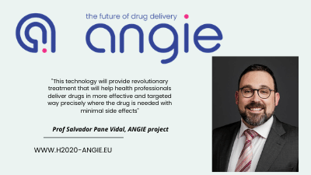

Facebook

**Tiny mobile magnetic devices being developed for target drug delivery**

A new research project, ANGIE, tasked with creating a radical new technology for localised, targeted drug delivery is launched on European Stroke Awareness Day, 11 May 2021.

The EU-funded ANGIE project will develop magnetically steerable wireless nanodevices that will be able to enter the body’s vascular system to target treatment at the site of the blood clot, unblock blood vessels and fight stroke from within.

The Stroke Alliance for Europe (SAFE) is part of the consortium and is responsible for disseminating information about ANGIE to the stroke community.

[www.h2020-angie.eu](http://www.h2020-angie.eu/)

