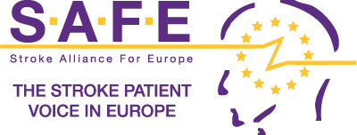
Application for board member role
(Please complete all sections)

Full name:
Name of member stroke support organisation: | .
Position held in member stroke support organisation:
Country of member stroke support organisation: | .

What contribution do you hope to make to SAFE and the stroke patient community as a member of the board?

What personal, expertise and professional strengths will you bring to SAFE and the stroke community? Mention any relevant experience.
.

How would your election to the SAFE board benefit your organisation?
.

I confirm that the information contained in this application is correct.

Signature: |  |  | Date:

Once completed please return this form to the SAFE Secretariat at info@safestroke.eu

Completed application forms must be received by 6 October 2020

Documents you need to submit together with your application
☐ | A letter from your stroke support organisation supporting your nomination
☐ | A recent curriculum vitae.

